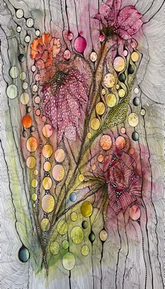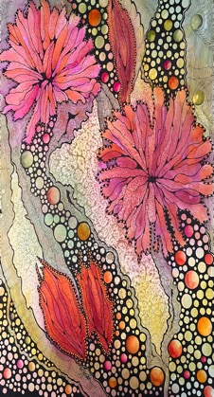 | Zen Doodle Class  Unleash Your Creative Self  Where: The Door Art Gallery  3073 W. Bullard Ave., Fresno, CA 93711  (559) 261-1610  When: Saturday June 1st, 2024  10:00 AM – 4:00 pm with an Hour Lunch  Instructor: Deborah Pepin Artist  Pepin61@msn.com  (559) 288-5507  Deborahpepin.com.  Doodling is an Expressive Art Form  There are no rules, and you simply cannot fail. In this workshop we will play, forming shapes of color then working with your personal expressive style. Each piece is extremely unique. No two are ever alike. Class is $140.00 and all materials are provided to create your unique art pieces. Class size is limited, and a $50.00 deposit is required to hold your seat.

